1. Go to GOOGLE and search “Sequel Server Download”

OR

1. Follow This link:

[SQL Server Downloads | Microsoft](https://www.microsoft.com/en-us/sql-server/sql-server-downloads)

1. You will get a screen as below:

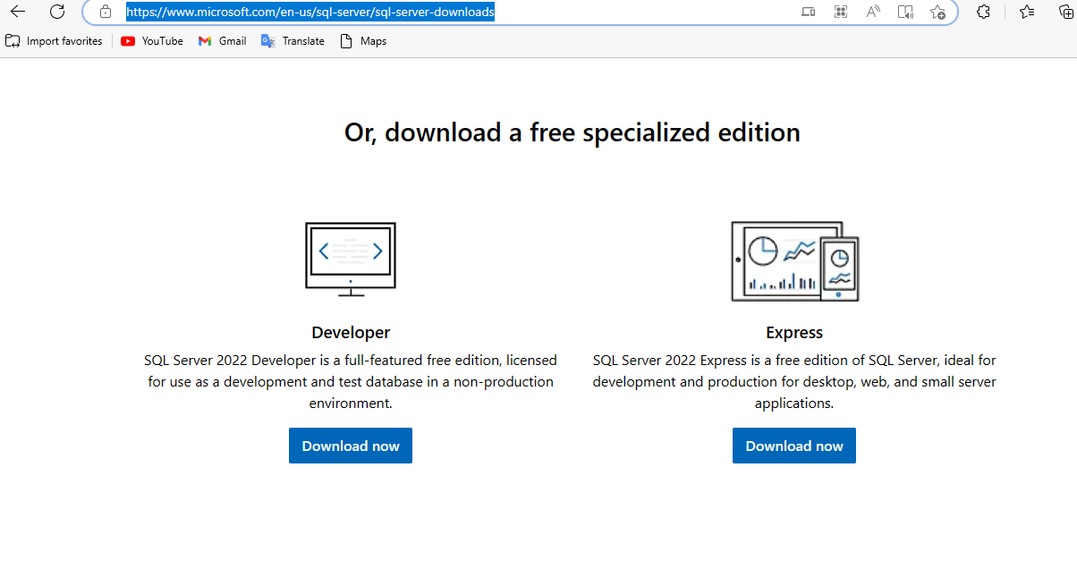

1. You can download the Developer edition. Just click the “Download Now” Button.
2. You will see the file downloaded down on your browser and on your “Downloads” folder. It’s like 4.1 mbs only.

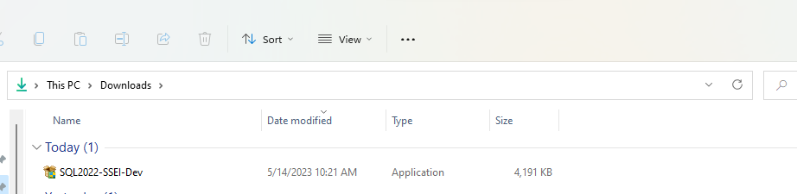

1. Now, copy this file and take it to your “Local Disc C”. You can have a folder just for this somewhere where everything else appertaining to it will be stored.

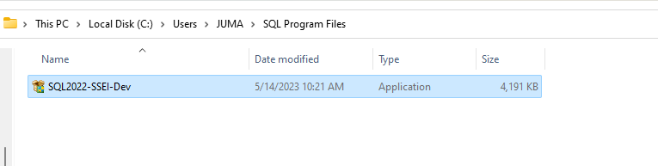

So, here, you can see I created a folder called “SQL Program Files” under my Local Disc C folders shown.

1. Double click on the file “SQL2022-SSEI-Dev” that you have copied here and follow the installation prompts.
2. Click Yes on allowing the app to make changes on your device.
3. You will get the following window, for which I want you to choose “Basic”:

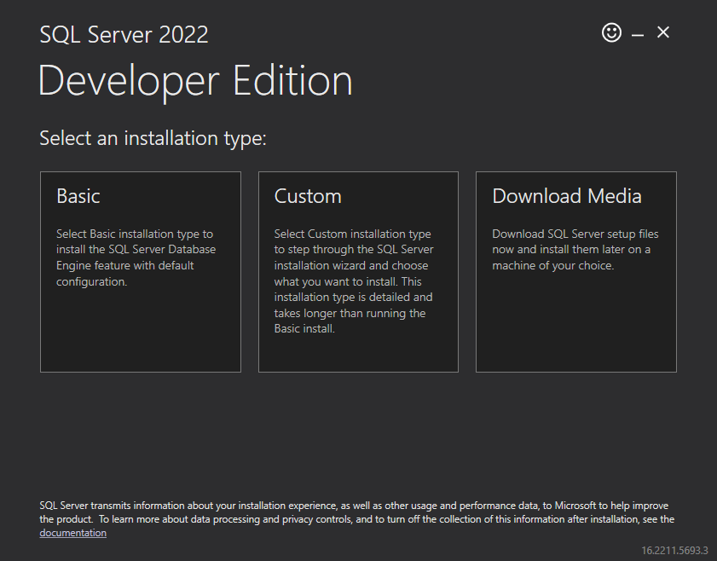

1. Read the terms and conditions that follow and click “ACCEPT”.
2. The following window will now do the actual installation of the MSSQL server on your device. You can choose not to change the location and use the default provided. Just click install. It is like almost 1.2GB, so, feel free to take a cup of coffee as you wait.

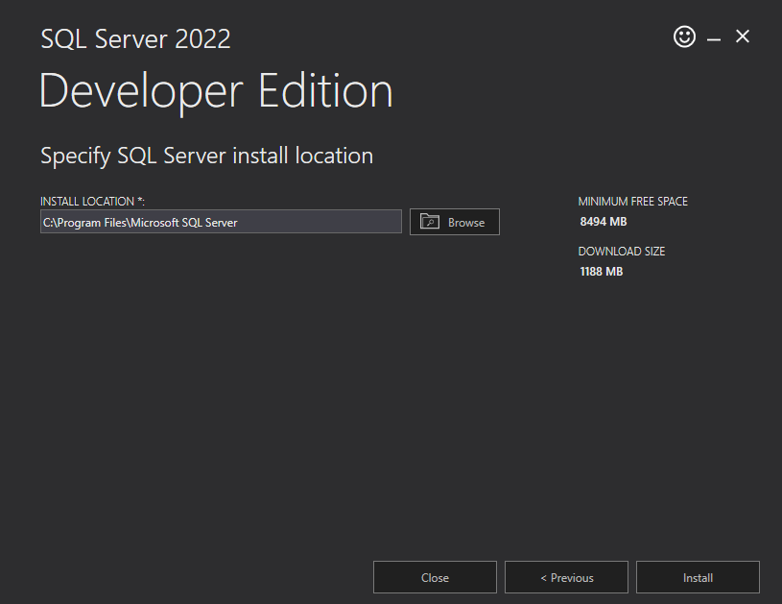

1. In the next window after the long wait, click on “install as SSMS (in full it is Sequel Server management System).

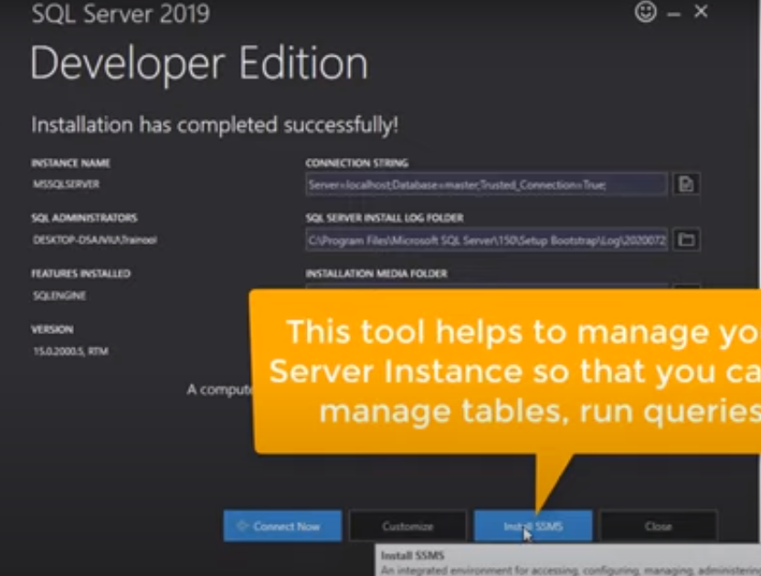

The SSMS tool will help to manage your SQL Server Instance so that you can easily manage tables, run queries, etc.

It opens a new Brower tab. Go to the browser and scroll down to the part where you see “Download as SSMS” as shown below:

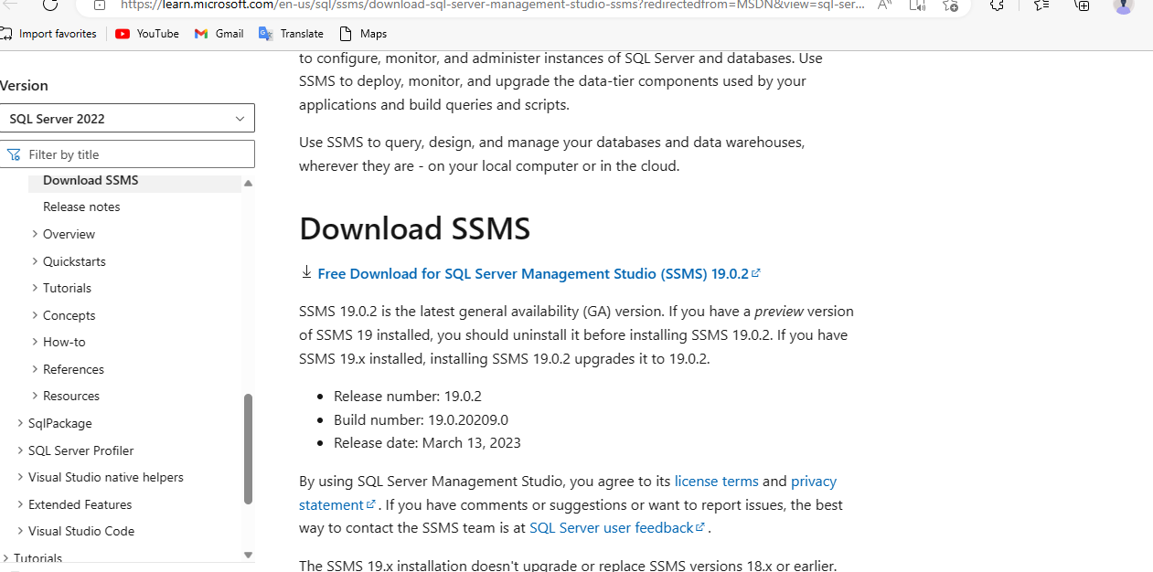

Click on the link for downloading in blue as shown above.

1. A file of SSMS will be downloaded to your computer. It is almost 630 mbs.
2. Copy this file, and remember the folder we had created before? Paste it in this folder.
3. So, double-click on the file name and install. This would also take some time.
4. Once it has been installed. Just close the installation windows.

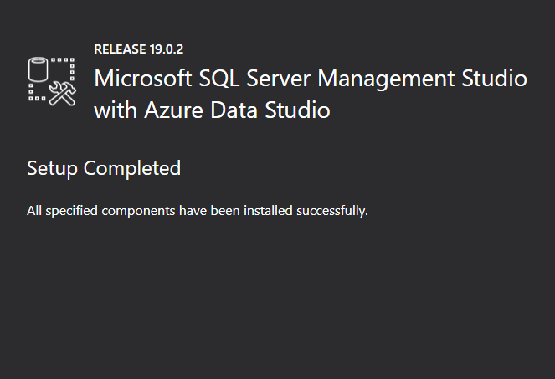

1. Go to Windows “Start key” and search for “sql server”. Then open. You are ready to go!

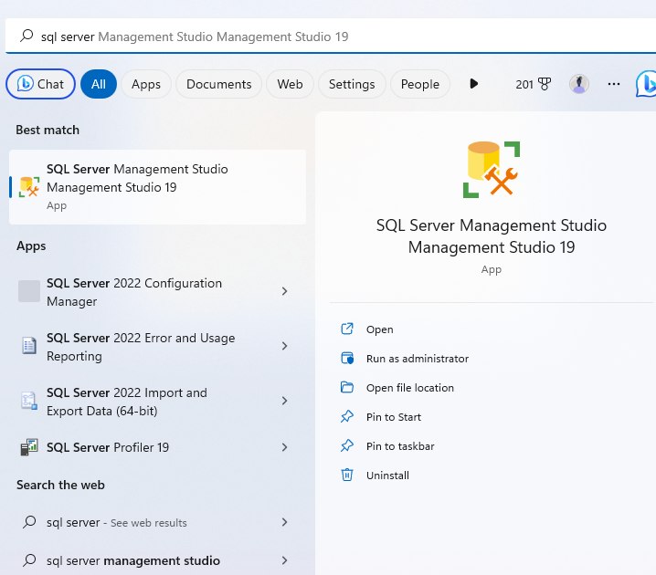

1. On the pop-up window the follows, just click connect.

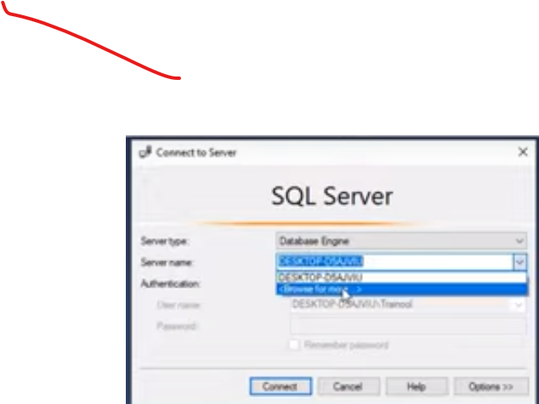

1. To check the server name, you can go to “File” then choose “New”, then “query with current connection”. You will then write the following:

SELECT @@SERVERNAME

You can also check the version using the same logic:

SELECT @@VERSION

After keying these commands, you need to click on “execute” on the ribbon or just press “F5”.